June Newsletter
Volume 1 Issue 2
Official Newsletter of Division 13S

Whether you are cramming for finals or searching for a summer job, this time of year can stress anyone out. Knowing how to handle stress and manage time will help give you an easy and stress free end to school and start to summer!

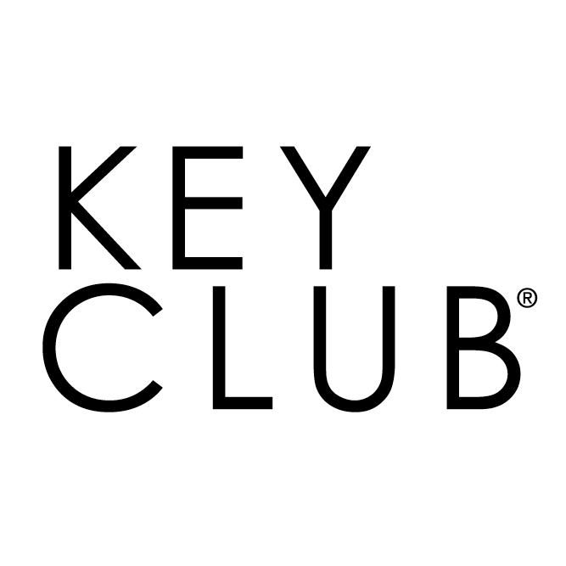
In this issue!

Introduction 1

Circle K 2

Summer Activity 3

Officer Training 4

Personal Note 4
Contacts……………… .4

K E Y C L U B
®
- Learn to plan. Disorganization can breed stress. When possible, take on projects one at a time and work on them until completed.

- Be a positive person. Avoid criticizing others. Learn to praise the things you like in others. Focus upon the good qualities those around you possess. Be sure to give yourself credit and appreciate your own good qualities, as well.
- Be aware of how you spend your time each day.

- Set priorities so you know what’s important and what’s not.

- Establish goals for yourself, including personal and school aspirations.

- Develop habits to get what you want out of life.

Some of you are quickly approaching the end of your high school career. This means your time in Key Club is soon over; however your service does not have to end here. What’s next?
Circle K is the leadership and community organization sponsored by Kiwanis at the collegiate level. This organization allows you to meet and work with other college students all over the world. Circle K provides a unique opportunity in your college experience!

The Eliminate Project
Neonatal tetanus kills nearly 60,000 newborn babies each year. Maternal tetanus acts severely as well, killing a significant number of women.

Just like Key Club, Circle K pairs with UNICEF to eliminate MNT from the Earth entirely, raising money for vaccines, syringes, staff, and more.


So what if my college doesn’t have a CKI club?

If your college does not have a CKI club when you arrive, don’t stop there, look into chartering one!
Visit http://www.circlek.org/Join/Membership/Chartering.aspx
For more information!
Be the change you wish to see!

What’s in YOUR future?

So what do they Do?
The Six Cents Initiative
Oral rehydration salts (ORS) are a cheap and effective way to provide rehydration to those that are suffering from dehydration.

CKI has paired with UNICEF creating The Six Cents initiative, to provide struggling children all over the world with these salts to survive.
Don’t let the end of highschool stop you from serving others and your community!
For more information about CKI visit
http://www.circlek.org/home.aspx
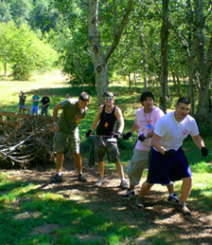


3

Alex’s Lemonade Stand

Alex’s Lemonade Stand is a national foundation dedicated to funding research for new cures and treatments for childhood cancer.
Alexandra Scott was diagnosed with neuroblastoma before her birth on January 18, 1996. Following her 4th birthday and release from the hospital in 2000, Alex held a lemonade stand, raising $2,000 for doctors to “help other kids like they helped her”.
Since Alex’s death in 2004, ALSF has continued raising money to fight the ongoing battle of childhood cancer.
For more information, visit
https://www.alexslemonade.org/

K E Y C L U B

Summer activity

The end of a school year does not put an end to service. Our communities and people world- wide need help year round. Put yourselves to work over summer and see what you can accomplish!



Brighten up your Community

Perhaps your parks or playgrounds are looking a bit worn down. Gather your club or a group of members together and dedicate a day to pulling weeds, planting flowers, and cleaning up trash.
With approval from your town administration you could even paint a meaningful mural or repaint old play equipment.
Possibilities are endless! Remember, the more hands you have, the more rewarding the outcome!
Helpful Links:
http://www.useful-community-development.org/cleaning-up-your-neighborhood-park.html
https://www.pinterest.com/sarahhodgkins/school-playground-mural-ideas/?lp=true


.
4 www. keyclub.org

OFFICER training

Contact Information
Maddie Smith (LTG)
Cell: 717-353-0768
Email: pakcltg13s@gmail.com
Ryan Hartman (Zone Administrator)
Cell: 717-802-2770
Email: zone3administrator@pakeyclub.org

Well organized executive boards are vital parts of a function Key Club. Each member of the executive board holds a unique position with specific responsibilities. It is important that each member knows their responsibilities and receives the proper training.

If your club is struggling with ideas for this year’s officer training, please do not hesitate to email your Lieutenant Governor. Contact information is listed in the box below. I have also attached helpful links to jump start your planning.

I would be very excited and honored to aid in officer trainings!
Personal Note from your LTG
I am very excited to work with each of your clubs. I am glad to have heard from some of your advisors and look forward to planning and attending future events with all of you.
I want to thank you all for another school year dedicated to service and urge each of you to stay active during summer. Without the help of each member, Key Club would not be able to do the amazing things we do.



